
Sacred Heart – Growing Outside

Wednesday 20th February 2024
Heavy rain showers

Weather:

Children:
Year 3, 4, 5 and 6

Microgreens

Today, in Growing Outside, the children were looking forward to planting seeds. Seeds are grown for so many reasons: as food, to give us oxygen, to make our surroundings look beautiful, for scent and colour and for homes for insects, creatures and birds. Usually, when we plant for food, it takes a long time before we are able to harvest it to eat, so we decided to be sneaky and grow something called a ‘Microgreen.’ We worked out that ‘micro’ means small (like microscope), so they were able to work out that we would be growing something that was small!

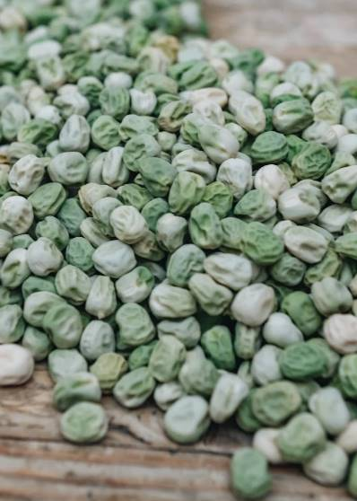
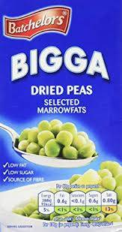
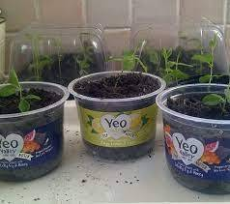
Growing seeds is normally done with the aim of producing a full-sized plant or vegetable but there really are no rules when it comes to gardening and growing food! Microgreens are an experiment. The seeds of a plant are taken and grown to seedling stage to see if they taste nice. Did you know that the seedlings of many plants have much more flavour than the adult plant because the taste is packed into a tiny seedling instead of a large plant that has taken on more water? This is a bit like making a drink of Vimto. The more water you add, the weaker the taste becomes. Microgreens are packed full of nutrients and make a healthy snack.

The children put compost into their re-used plastic yogurt pots. We were experimenting with peas, although you can try a range of seeds like beetroot or even mustard.

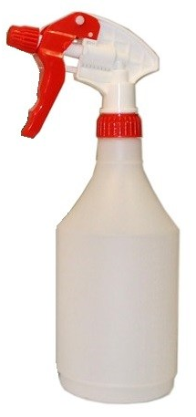
Once the children had sprinkled the seeds over the compost, they covered them up with a thin layer of compost before spraying gently with water. Normally, we give our seeds space to grow, but with microgreens, we sow them very closely together so that we have lots of stems to try and to help restrict their growth. I was impressed that some of the children were able to tell me that the reason we cover seeds with compost, is to make sure they are warm because that helps them to start growing.

Finally, the children labelled their seed trays and suggested that they put them on a warm, sunny window ledge. These will be going home today for the children to look after, but I’ve done a tray of peas for each of the Junior teachers to keep in their classrooms so that everyone can compare how they are growing with the ones they have at home. To speed up the germination of the seeds, you can even put a layer of clingfilm or clear plastic over the top. This traps the heat of the sun and warms up the soil – a bit like a mini greenhouse.
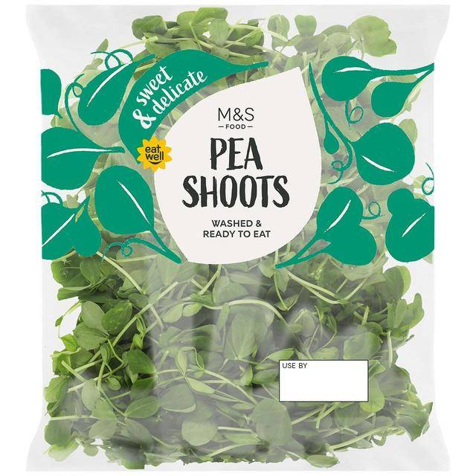
Did you know that you can buy microgreens like pea shoots from the supermarket? They are expensive to buy, and some fancy restaurants charge a lot of money for meals sprinkled with microgreens, but they are so cheap and easy to grow yourself! We even re-used old plastic pots to grow our seeds in.
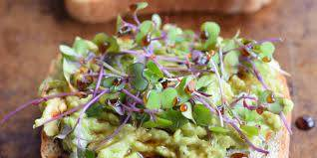

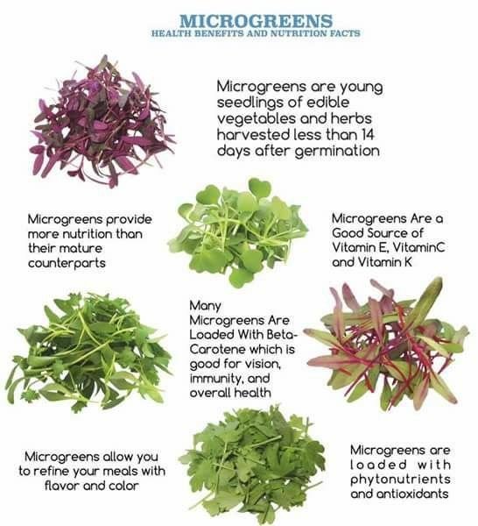
The pea shoots only take 7-14 days to grow. Remember to spray them/water them gently every day, and you’ll all have a tasty, healthy treat – yum! Eating pea shoots is a very strange experience as the stems and leaves taste exactly like actual peas from a pea pod. I can’t wait to hear what you think of them, especially those of you who said you’ve never tried peas before.

Well done everyone.

Mrs Grainger

