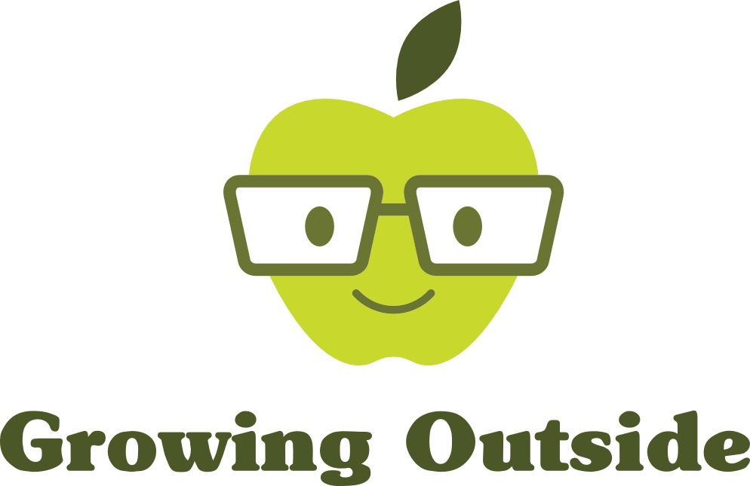
Sacred Heart – Growing Outside!

Tuesday 27th September 2016
Warm and mostly dry

Weather:
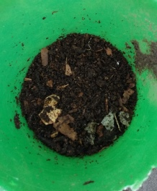

Children:
Year 4

COMPOST!

Today we had a big job to do – we were going to build three new Compost Bins.

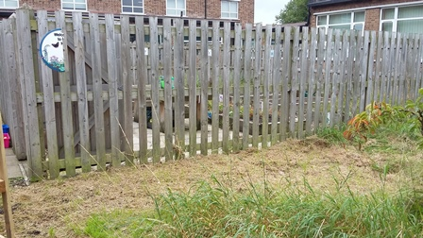
But first, what is compost? Some children thought it was mud, dirt or soil. In many ways they were right, but proper compost is made completely from rotted or rotting organic matter. That means things that are found naturally in the garden, such as grass clippings, leaves and old bits of fruit or vegetables.
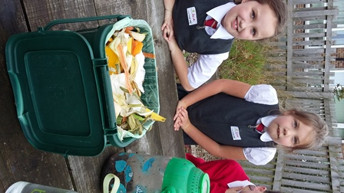
Of course if you’ve been peeling carrots or have leftover apple cores then they can come from the kitchen or your classroom and be added too!
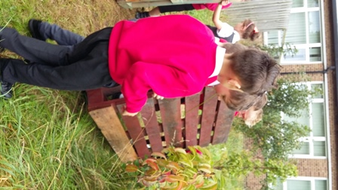
To build the bins, we used Pallets, which are big wooden flat squares used to allow fork lift trucks to move heavy things like bricks and slabs around. We got them for free, as they are often not needed once they’ve done their job.

We worked out how many pallets we’d need to build a four sided bin, with no base and using the existing fence for one side. Then we worked out how many for three bins, if you used the side of the first bin as a side of the next bin. It’s funny because some children thought they had “Got out of maths” to do gardening!!

The answer was seven, and we then proceeded to tie the big pallets to each other and the fence using Cable Ties – a very clever invention!

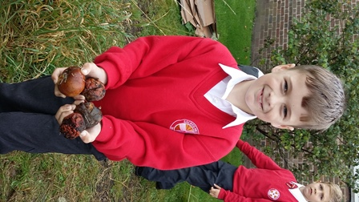
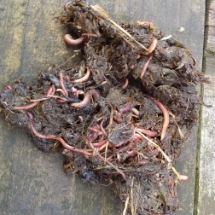
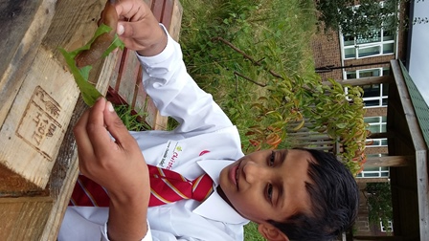
The children had great fun looking around the garden to find things to add to our compost. However, all of the organic matter wouldn’t do anything at all if it wasn’t for the WORMS. Actually not just the worms – many other creatures help to break down all the rotting stuff – slugs, snails, woodlice.

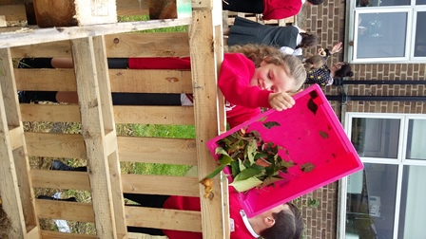
I had brought some worms from my compost bin at home to start off the party – these are mostly a kind of worm called a Brandling worm – small red worms that are brilliant at eating tons of food and then pooping it out the other end.

Yes, that is what everyone came to realise, that compost, or soil is in fact mostly made up of worm poo!! I didn’t buy these worms specially – they just turn up when they find out that there’s a compost heap with some tasty stuff in it.
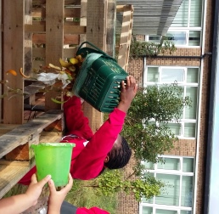
The children dug for worms and had a great time filling one of the bins with compostable material. When that one is full, we will leave it to rot down and move on to the next one. We should end up with three bins which we can keep rotating – “FEED ME”, “LEAVE ME” and “USE ME” !!

We had great fun and learnt a lot today – Well done!

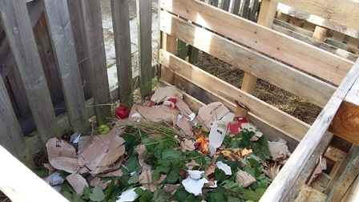
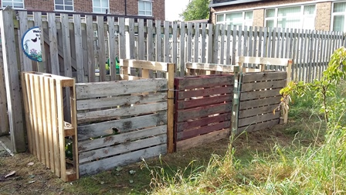
Mandy

